DEFECT LOG

Project Name : VKC PRIDE Webpage Tested By : M.VIGNESH

Module Name : VKC pride Men page Issue ID : #VKC 2118
Tested On : 04/10/2021

Defect Priority : High

Defect Severity : High

Title:
Wrong Product color image is displayed.

Steps to Reproduce:

Description:
1. Select ‘GENTS’ from selection categories.
2. Place a Mouse Pointer on Particular Product Image.
3. Click on Particular "Product Image".
4. Select the product "size".
5. Choose a color from the option.
6. Check the selected color, whether changed or not.

Expected Results:
1. "GENTS" Product Page should be opened.
2. Following icons should be displayed.
a.Product.Price
b. Product Size
3. Particular "Product" Page should be opened and the following Information should be displayed:
a. Product Image
b. Product Name
c. Product price
d. Size: 6 7 8 9 10
e. Availability color (Black, Brown)
4. Select the product size as 10.
5. Select the color as brown.
6. The product image needs to be displayed as brown color.

Actual Results:
1. "GENTS" Product Page should be opened.
2. Following icons should be displayed.
a. Product Price
b. Product Size
3. Particular "Product" Page should be opened and the following Information should be displayed:
a. Product Image
b. Product Name
c. Product price
d. Size: 6 7 8 9 10
e. Availability color (Black, Brown)
4. Select the product size as 10.
5. Select the product color as brown.
6. The product color is displaying in Black color.

.
Screenshot for defect:
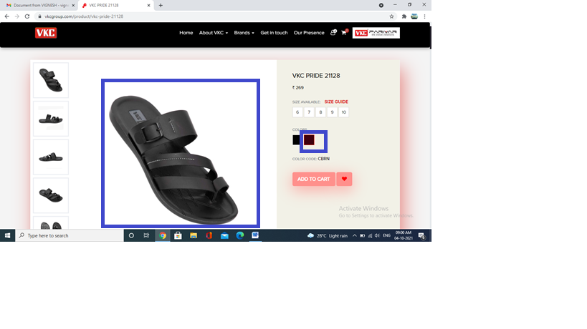

DEFECT LOG

Project Name : VKC PRIDE Webpage Tested By : M.VIGNESH

Module Name : VKC pride web page Issue Id : PG1309

Tested On : 04/10/2021

Defect Priority : High

Defect Severity: High

Title:
This page does not showing the product between the selected range of price.

Steps to Reproduce:

Description:
1. Select ‘BOYS’ from selection categories.
2. Select the range of price .
3. Check the range of product only shown or not.
Expected Results:
1. "BOYS" Product Page should be opened.
2. Product" Page should be opened and the following Information should be displayed:
a. selection
b. Price
c. For
d type
e. brand
4. Select the price between range.
5. Select the boys “For” categories
6. The page should be displayed the range of the product prize.

Actual Results:
1. "BOYS" Product Page should be opened.
2. Product" Page should be opened and the following Information should be displayed:
a. selection
b. Price
c. For
d type
e. brand
4. Select the price between range.
5. Select the boys “For” categories
6. The page does not show the between range of the product.

SCREENSHOT FOR THE DEFECT:

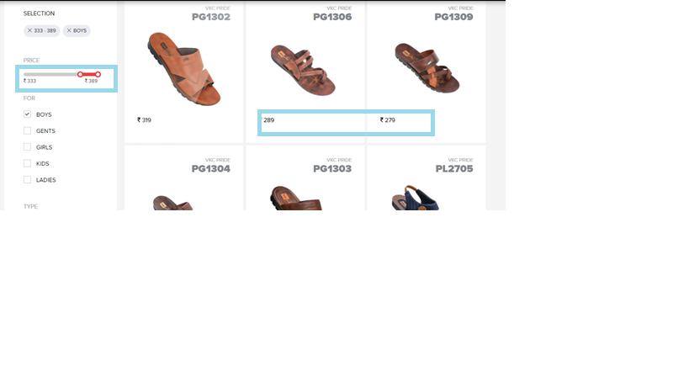

DEFECT LOG

Project Name : VKC PRIDE Webpage Tested By : M.VIGNESH

Module Name : VKC pride web page Issue Id : PG1309

Tested On : 04/10/2021

Defect Priority : High

Defect Severity: High

Title:
This page does not showing product of particular price.

Steps to Reproduce:

Description:
1. Select ‘BOYS’ from selection categories.
2. Select the price.
3. Select the product price as same value for minimum and maximum in the range(333-333).

Expected Results:
1. "BOYS" Product Page should be opened.
2. Product" Page should be opened and the following Information should be displayed:
a. selection
b. Price
c. For
d type
e. brand
3. Select the same price for minimum and maximum range [333-333].
4. Select the boys option from the “For” categories
5. The page should be displayed only the selected range of the product.

Actual Results:
1. "BOYS" Product Page should be opened.
2. Product" Page should be opened and the following Information should be displayed:
a. selection
b. Price
c. For
d type
e. brand
3. Select the same price for minimum and maximum range [333-333].
4. Select the boys option from the “For” categories
5. The page does not showig the particular price of the product.

.

SCREENSHOT FOR THE DEFECT:

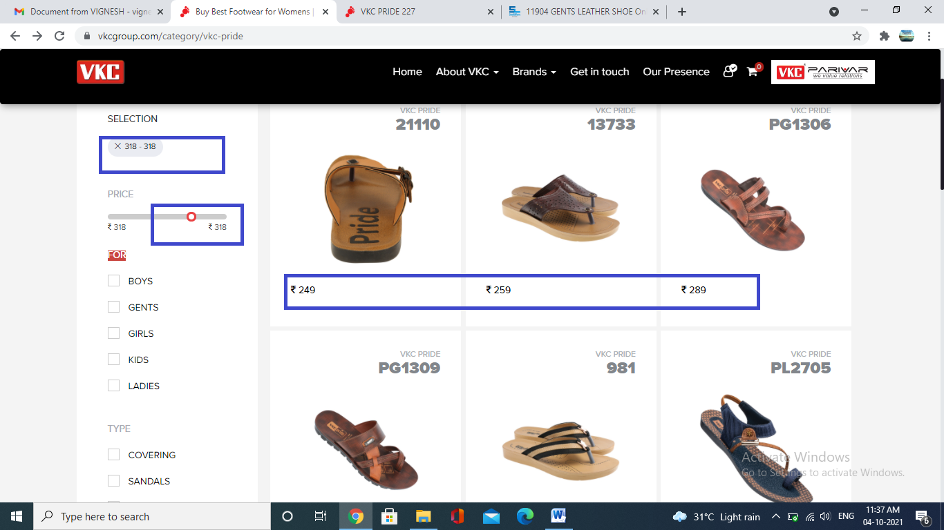

DEFECT LOG

Project Name : VKC PRIDE Webpage Tested By : M.VIGNESH

Module Name : VKC pride web page Issue Id : PG1307

Tested On : 04/10/2021

Defect Priority : High

Defect Severity: High

Title:
This page does not showing particular FOR product.

Steps to Reproduce:

Description:
1. Select ‘GIRLS’ from selection categories.
2. Select the price.

Expected Results:
1. "GIRLS" Product Page should be opened.
2. Product" Page should be opened and the following Information should be displayed:
a. selection
b. Price
c. For
d type
e. brand
3. Select the GIRLS option from the “For” categories
4. The page should be displayed only the selected for product.

Actual Results:
1. "GIRLS" Product Page should be opened.
2. Product" Page should be opened and the following Information should be displayed:
a. selection
b. Price
c. For
d type
e. brand

3. Select the boys option from the “For” categories
6. The page does not show the particular FOR product(showing boys and girls category product).

.

SCREENSHOT FOR THE DEFECT:

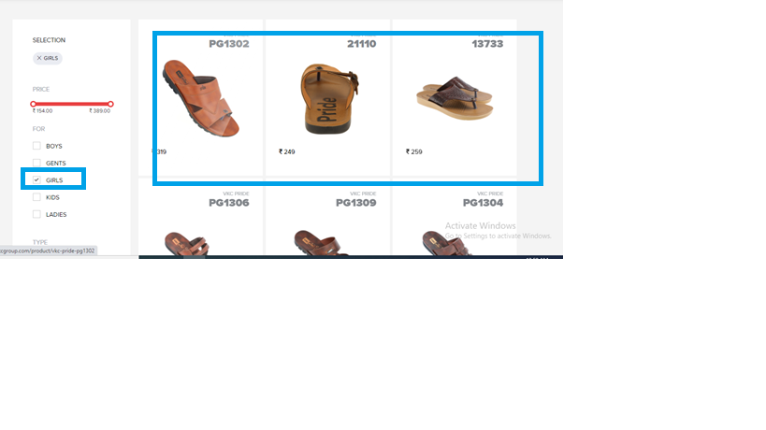

DEFECT LOG

Project Name : VKC PRIDE Webpage Tested By : M.VIGNESH

Module Name : VKC pride web page Issue Id : PG 528

Tested On : 04/10/2021

Defect Priority : High

Defect Severity: High

Title:
This page showing available size in different manner (not ascending or descending)

Steps to Reproduce:

Description:
1. Select ‘GENTS’ from selection categories.
2. Place a Mouse Pointer on Particular Product Image.
3. Click on Particular "Product Image".
4. Check the available size number are printed in increasing or decreasing manner.

Expected Results:
1. "GENTS" Product Page should be opened.
2. Following icons should be displayed.
a. Product Price
b. Product Size
3. Particular "Product" Page should be opened and the following Information should be displayed:
a. Product Image
b. Product Name
c. Product price
d. Available size
e. color
f. code
g. Add to Cart
h. Add to Wishlist
4. The available size showing in same manner (Increment/Decrement)

Actual Results:
1. "GENTS" Product Page should be opened.
2. Following icons should be displayed.
a. Product Price
b. Product Size
3. Particular "Product" Page should be opened and the following Information should be displayed:
a. Product Image
b. Product Name
c. Product price
d. Available Size
e. color
f. code
g. Add to Cart
h. Add to Wishlist
4. The available size number not showing in either increment or decrement manner.

SCREENSHOT FOR THE DEFECT:

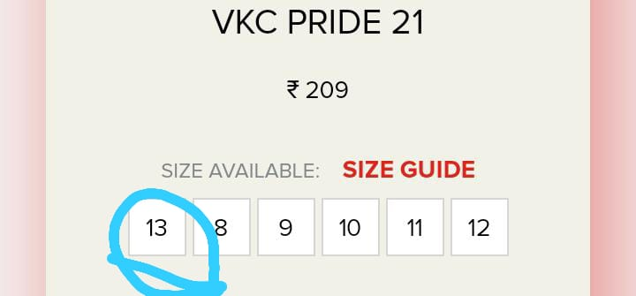

DEFECT LOG

Project Name : VKC PRIDE Webpage Tested By : M.VIGNESH

Module Name : VKC pride web page Issue Id : PG1309

Tested On : 04/10/2021

Defect Priority : High

Defect Severity: High

Title:
The brands category option does not working.

Steps to Reproduce:

Description:
1. Select ‘BOYS’ from selection categories.
2. Select the price.
3. Select the product price and type.
4. Select the brand under the brand catergory.
Expected Results:
1. "BOYS" Product Page should be opened.
2. Product" Page should be opened and the following Information should be displayed:
a. selection
b. Price
c. For
d type
e. brand
4. Select the price between range.
5. Select the boys “For” categories
6. Select the brand from brand category.
6. The page should display only the selected brand.

Actual Results:
1. "BOYS" Product Page should be opened.
2. Product" Page should be opened and the following Information should be displayed:
a. selection
b. Price
c. For
d type
e. brand
4. Select the price between range.
5. Select the boys “For” categories
6. Select the brand from brand category.
7. Before selecting the brand option also it’s showing only the VKC Pride brand.
6. After selecting the brand option, it’s showing only VKC Pride there is no change in website (brand option is not working).

SCREENSHOT FOR THE DEFECT: (Before selection)
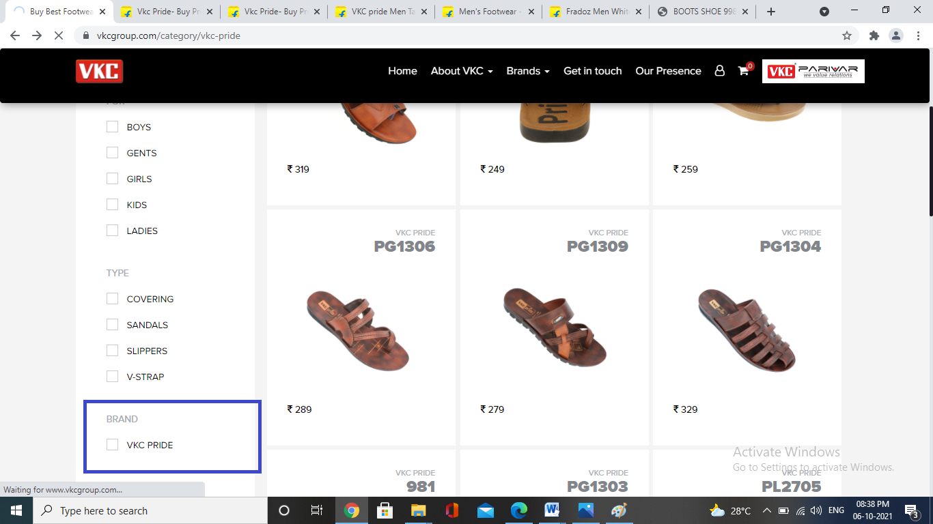

After Selection:
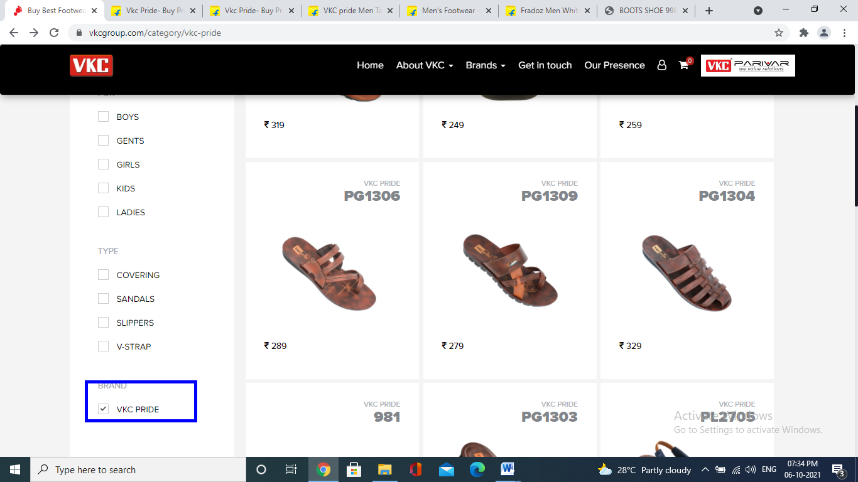

DEFECT LOG

Project Name : VKC PRIDE Webpage Tested By : M.VIGNESH

Module Name : VKC pride web page Issue Id : PG1309

Tested On : 04/10/2021

Defect Priority : High

Defect Severity: High

Title:
This page whislist option does not working
Steps to Reproduce:

Description:
1. Select ‘BOYS’ from selection categories.
2. Select the range of price .
3. Product Page should be opened.
Expected Results:
1. "BOYS" Product Page should be opened.
2. Product" Page should be opened and the following Information should be displayed:
a. selection
b. Price
c. For
d type
e. brand
3. Select the boys “For” categories
4. The product page should be displayed and if product is out of stock means ,add to whishlist.

Actual Results:
1. "BOYS" Product Page should be opened.
2. Product" Page should be opened and the following Information should be displayed:
a. selection
b. Price
c. For
d type
e. brand

5. The product page should be displayed and that product is out of stock means add to whishlist ,is not working

SCREENSHOT FOR THE DEFECT:
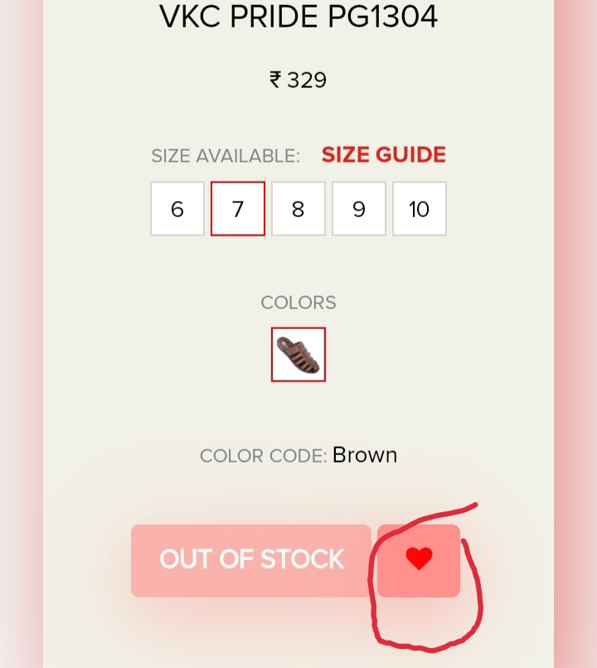

DEFECT LOG

Project Name : VKC PRIDE Webpage Tested By : M.VIGNESH

Module Name : VKC pride web page Issue Id : PG1309

Tested On : 04/10/2021

Defect Priority : High

Defect Severity: High

Title:
This page out of stock is option does not working
Steps to Reproduce:

Description:
1. Select ‘BOYS’ from selection categories.
2. Select the range of price .
3. Product Page should be opened.
Expected Results:
1. "BOYS" Product Page should be opened.
2. Product" Page should be opened and the following Information should be displayed:
a. selection
b. Price
c. For
d type
e. brand
3. Select the boys “For” categories
4. The product page should be displayed and if product is out of stock.,click that option after only result viewed

Actual Results:
1. "BOYS" Product Page should be opened.
2. Product" Page should be opened and the following Information should be displayed:
a. selection
b. Price
c. For
d type
e. brand

5. The product page should be displayed and that product is out of stock ,but here out of stock option is hidden.

SCREENSHOT FOR THE DEFECT:

